Template for Extended Abstracts for the 17th International Conference on Urban Drainage

First A. Author*¹, Second B. Author^{1,2}, and Third C. Author²

1 Authors’ Department, Institute, Organization, Country
2 Author’s Department, Institute, Organization, Country
(*Presenting Author, e-mail: ccc@aaa.bbb)

Keywords: One; Two; Three; Four; Five; Six (up to 6 words)

Abstract

This document presents the instructions needed to prepare the extended abstract (max 4 pages in length including references and a short biography) to be included in the proceedings of the conference. All abstracts should be written in English. In order to achieve graphical consistency, the extended abstract should be written using Microsoft Word [1]. It should start with the abstract’s title, authors, authors’ affiliation and corresponding e-mail [2] followed by the keywords (up to six) [3]. Please, indicate the author making the presentation with an asterisk.

Format: The abstract should be written in MS Word. Please use A4/letter page set-up and make all margins (top, bottom, left, right) 25 mm wide. Please use single-spaced 12-point Times New Roman font [4]. Subheadings should be bold. Justify the body of the text both left and right. The length of the Extended Abstract should be max 4 pages, including references.

Content: Explain the aim and scope of your study, materials and methods used, the results obtained and main conclusions reached. The figures/photographs can be placed in the abstract.

Biography of speaker: A short biography with a recent photo of the presenting author should be included in the extended abstract. The size of the photo is preferably 35 × 45 mm.

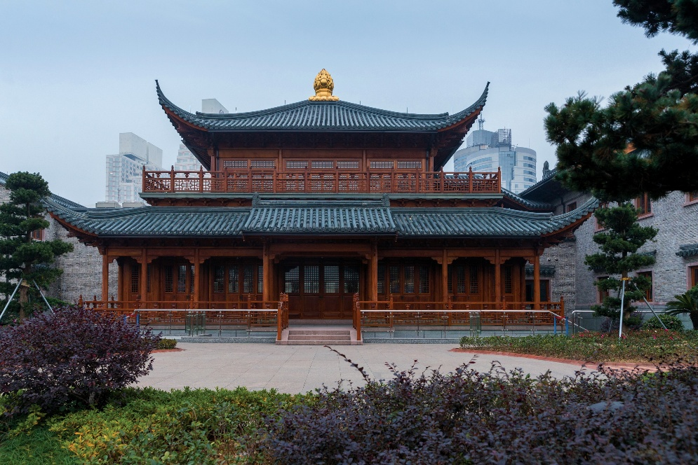
Figure.1 Example figures for the extended abstract.

Acknowledgment

The authors would like to express the appreciation for the financial support of the sponsors [Grant Number: XXXXXXX].

References

Format for references should be in APA style:
[1] Lin, P. (2007). “A fixed-grid model for simulation of a moving body in free surface flows.” Computers & Fluids, 36, 549-561.
[2] Lin, P., and Xiao, H. (2016). “Numerical Simulation of Dam Overtopping Events Caused by the Landslide Generated Impulse Waves in Mountainous Reservoirs.” 12th Inter. Conf. on Hydroscience & Engineering, Tainan, Taiwan.
[3] Lin, P. (2008). “Numerical modeling of water waves.” Taylor & Francis.

Biography


The author is a Professor in the School of Engineering at the University of ABC where he has been a faculty member since 2000. He is the School's Deputy Director. From 2013–2019, he held the Professorship for Innovation in Engineering Education. The author completed his Ph.D. at ABC University and his undergraduate studies at EFG University. His research interests lie in the area of water engineering, ranging from theory to design to implementation. He has collaborated actively with researchers in several other disciplines of engineering.

