Article Title
Author A^{1,*}, Author B² and Author C^{1,2} (Full names)
¹ School of Aeronautics, Northwestern Polytechnical University, Xi’an 710072, China
² Institute of Mechanics, Chinese Academy of Sciences, Beijing 100190, China
(Affiliations should include Sub-organization, Organization, City, Post code, Country)
Abstract
Text for this section ...
(The Abstract should summarize the aim or purpose, methodology, results or findings and conclusions of the article. A long abstract within two pages is preferred. If Figures or Tables are used, please put them in the following style.)
...
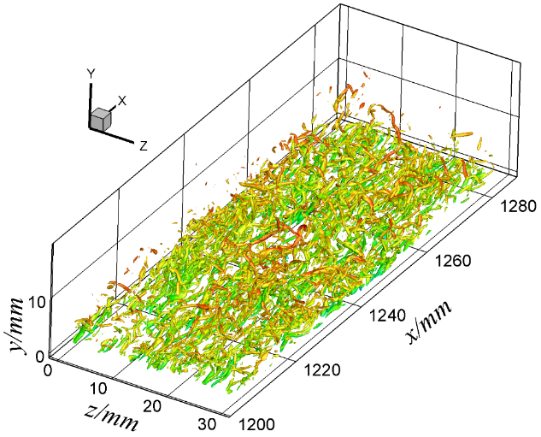 | 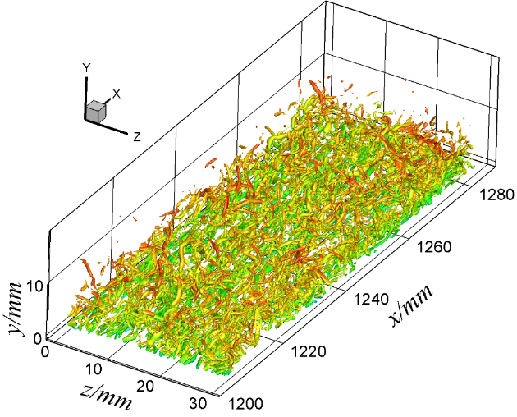
(a) NC | (b) B1H1
Fig. 1 Iso-surface of Q = 0.2 to visualize vortical structures (colored by streamwise velocity)
Table 1 Control parameters
Case | Δv | ΔT
NC | 0 | 0
B1H1 | 0.1% | 1%
B1 | 0.1% | 0
H1 | 0 | 1%
Keywords: Three to ten keywords representing the main content of the article. Use a comma to separate each word(s).
Declarations: Please indicate whether your manuscript has been published or submitted for possible publication in a journal.
References (List 3 to 5 most important references that your manuscript cites according to the following style.)
- Jiang D, Mao M, Li J et al (2019) An implicit parallel UGKS solver for flows covering various regimes. Adv Aerodyn 1:8
- Cercignani C (2000) Rarefied gas dynamics: from basic concepts to actual calculations. Cambridge University Press, Cambridge
- ISSN International Centre (2006) The ISSN register. http://www.issn.org. Accessed 20 Feb 2007

